Assignment 1

Travel agency

Student(s):

* S1
* S2

**Group:**

**Contents**

I Project specification **3**

1.1 Domain Model Diagram 3

II Use-Case model **3**

2.1 Users and stakeholders 4

2.2 Use-Case identification 4

2.3 UML Use-Case diagram 4

III Architectural design **5**

3.1 Conceptual architecture 5

3.2 Package diagram 5

3.3 Class diagram 5

3.4 Database (E-R/Data model) diagram 6

3.5 Sequence diagram 6

3.6 Activity diagram 6

IV Supplementary specifications **6**

4.1 Non-functional requirements 6

4.2 Design constraints 6

V Testing **7**

5.1 Testing methods/frameworks 7

5.2 Future improvements 7

VI Bibliography **7**

# I Project specification

TheTravelling Agencyshould be able to:

1.add vacation destination

2.add vacation packages for aspecific destinationa.shouldcontaininformation:name,price,period,extradetails,numberof people that can book the vacation

3.edit an existing vacation package

4.delete an existing vacation package

5.viewallitslistedvacationpackages(withstatus:BOOKED,NOT_BOOKED,IN_PROGRESS)

6.delete vacation destination

TheRegular Usershould be able to:

1.registerontheplatformusingsomecredentials(username/email-unique&password)

2.login on the platform

3.view allavailablevacation packages

4.filter vacation packages by destination/price/period

5.book a vacation

6.view all its booked vacations

## 1.1 Domain Model Diagram

*< Schema Domain Model a aplicatiei. Se va discuta la laborator. />*

# II Use-Case model

*< Se va scrie o mica introducere./>*

## 2.1 Users and stakeholders

Users

Travel Agency

## 2.2 Use-Case identification

*< Aici se vor prezenta 3-4 use-case-uri mai importante din applicatie dupa urmatorul model*

***Nume Use case/Use case name: < Nume use-case>.***

***Nivel/Level: < User-Goal, Subfunction, Summary > .***

***Actor principal/Main actor: < Actorul scenariului> .***

***Scenariul principal de success/Main success scenario: <Descriere detaliata a scenariului>.***

***Extensie/Extension: <Un caz particular al scenariului, fie pozitiv sau negativ>***

*Se va discuta la laborator mai detaliat.*

*/>*

Travel Agency CRUD

## 2.3 UML Use-Case diagram

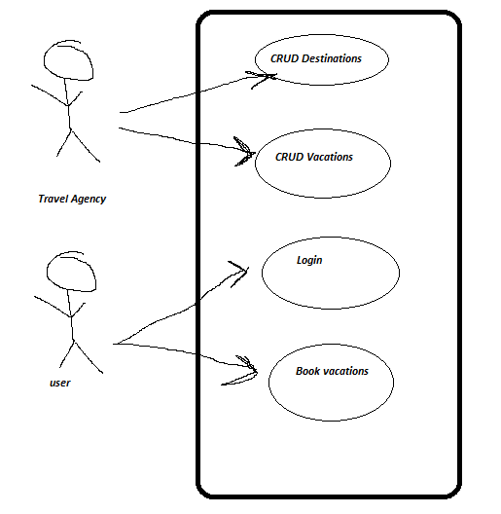

# III Architectural design

Layered architecture

## 3.1 Conceptual architecture

* **The presentation layer** contains all of the classes responsible for presenting the UI to the end-user or sending the response back to the client (in case we’re operating deep in the back-end).
* **The application layer** contains all the logic that is required by the application to meet its functional requirements and, at the same time, is not a part of the domain rules. In most systems that I've worked with, the application layer consisted of services orchestrating the domain objects to fulfill a use case scenario.
* **The domain layer**represents the underlying domain, mostly consisting of domain entities and, in some cases, services. Business rules, like invariants and algorithms, should all stay in this layer.
* **The infrastructure layer (also known as the persistence layer)**contains all the classes responsible for doing the technical stuff, like persisting the data in the database, like DAOs, repositories, or whatever else you’re using.

## 3.3 Class diagram

*< (Class Diagram)/>*

## 3.4 Database (E-R/Data model) diagram

*< (Data Model)/>*

## 3.5 Sequence diagram

*< (Sequence Diagram)/>*

## 3.6 Activity diagram

*< (Activity Diagram)/>*

# IV Supplementary specifications

*< Se va scrie o mica introducere./>*

## 4.1 Non-functional requirements

*< Specificatiile non-functionale ale aplicatiei. Se va discuta la laborator./>*

## 4.2 Design constraints

Technical constraints:●Desktop application, written inJava+Java Swing/JavaFX●Connectivity torelational database+ storage of data○each table in the database should contain at least 5 entries●Implement Data Access Layer usingORM(eg. Hibernate)●Implement the app usingLayered Architecture●Documentation●Validationoftheinputsonspecificflows(validdates,non-negativevalues, unique username etc.)